Genealogy with Betty W.
June 2023

Poem Corner:  Our Lady of Mercy Country Home  Our Lady of Mercy Country Home is where we live and where we roam.  From hall to hall and floor to floor we stop and look at our neighbor’s door.  As we go from eating to where we play, there’s stops we can make to enrich our day.  From Library to Game Room and then above our Country Store has lots in store.  We can even go to chapel to pray and spend quiet time any time of the day.  This place we stay in peace and care until we sleep our last sleep with loving care.  Don Binggeli  2020  Thing Our Mothers Taught Us  - My mother taught me RELIGION.  “You better pray that will come out of the carpet.”  - My mother taught me WISDOM.  “When you get my age, you’ll understand.”  - My mother taught me GENETICS.  “You’re just like your father!!”  Cards for Soldiers  On June 13th and June 15^{th,} we will be making cards for soldiers to send overseas. Most of our deployed service members are without their friends and family, so this will be a small way to show our appreciation and love for all they do for our country! Join us on June 13th and or June 15th in the Activity Room at 1:30 to help!!  June 2023 | June Birthdays  In astrology, those born June 1–20 are  Gemini’s Twins. Energetic and spontaneous, Geminis are great at connecting with others, making them ideal candidates for networking and sales. Those born June 21–30 are the Crabs of Cancer. Guided by their hearts,  Crabs are emotional and nurturing. They  create deep bonds with friends and comfortable homes that are warm and welcoming.  Father Keith Branson June 16  Raymond Arth June 17  Paul Kincaid June 27  Calvin Jack June 29  WELCOME Patricia Spahn, Irwin Broussard, Patricia Gradwohl, Sally Schmitt, and Perry Seaton!!! Our Lady of Mercy is glad to have you as a part of our family!!  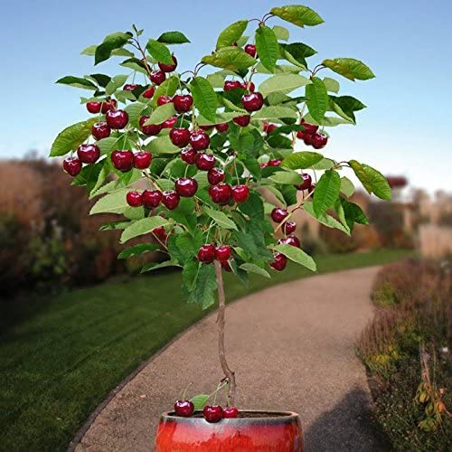  The Healing Foods: CHERRIES  Cherries are low in calories and chock full of fiber, vitamins, minerals, nutrients, and other good-for-you ingredients. You'll get vitamins C, A, and K. Each long-stemmed fruit delivers potassium, magnesium, and calcium too. They also bring antioxidants, like beta-carotene, and the essential nutrient choline. Below are three fun facts about cherries.  - A typical cherry tree produces 7,000 cherries!  - A cherry tree can grow 33 feet in height.  - A cherry tree can survive and produce fruit for up to 100 years! |  | Our Lady of Mercy
 |  |  | Care with Dignity | 2115 Maturana Drive Liberty MO 64068 | 816-781-5711
Celebrating June Important Dates to Remember

Music in the Park
Fridays in June

Genealogy with Betty W.
June 8, 15, 22, 29

Root Beer Floats
June 12

Coffee and Doughnuts
June 13

Cards for Soldiers
June 13 and 15

Flag Week (U.S.)
June 11–17

Father’s Day
June 18

Armchair Travel
June 19

Luau Craft
June 20

Mens Discussion Group
June 27

Luau!!
June 28

Music in the Park Dates
June 2nd: The New Red Onion Jazz Babies (Dixieland)

June 16th: Hula-Hale ‘O Kiakahi (Hawaiian)

June 23rd: Doug Talley Quartet (Jazz)

June 30^{th:} The Blue Grass Tornadoes
(Blue Grass)

Recipes to Remember:  June 2023  Cherry Delight  Ingredients  2 cups graham cracker crumbs (from about 15 [2 1/4- x 5-in.] crackers)  6 tablespoons (3 oz.) unsalted butter, melted  ¼ cup granulated sugar  ½ teaspoon kosher salt  ½ cup heavy whipping cream  2 (8-oz.) pkg. cream cheese, softened  ½ cup sour cream  1 cup (about 4 oz.) powdered sugar  1 teaspoon vanilla extract  1 (21-oz.) can cherry pie filling  Preheat oven to 350°F. Stir together graham cracker crumbs, melted butter, granulated sugar, and salt in a large bowl until combined. Press mixture evenly into bottom of an 11- x 7-inch baking dish. Bake in preheated oven until crust is toasty and edges are golden, 12 to 14 minutes. Transfer baking dish to a wire rack; let crust cool completely, about 45 minutes.  Beat heavy whipping cream in a medium bowl with an electric mixer on medium-high speed until stiff peaks form, about 1 minute. Set whipped cream aside. Beat cream cheese and sour cream in a large bowl with an electric mixer on medium speed until smooth, about 1 minute. Add powdered sugar and vanilla; beat until light and fluffy, about 2 minutes.  Fold half of whipped cream into cream cheese mixture using a rubber spatula until just combined; repeat with remaining whipped cream. Spoon cream cheese mixture into cooled crust; smooth top using a small offset spatula. Pour cherry pie filling over cream cheese layer, spreading to edges of cream cheese mixture. Cover and chill until filling is firm, about 2 hours. Cut into 10 bars, and serve immediately. | Slightly Off Broadway  Derby Hats |  | 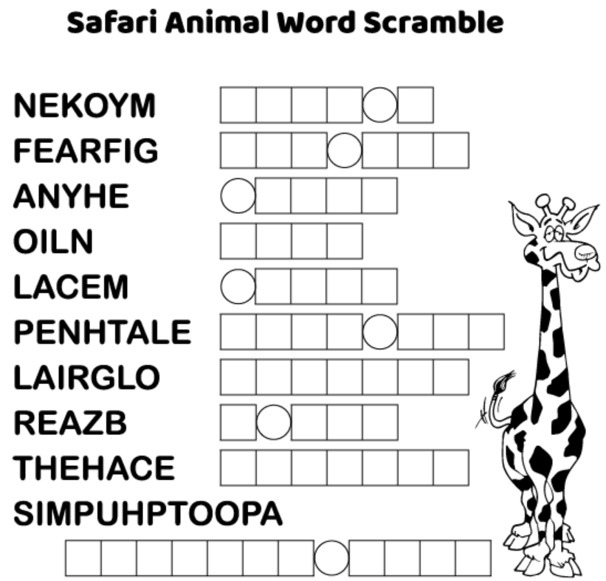  There was a time when Salem wanted to forget its sordid history. As late as 1895—over 200 years  after the hysteria—the Philadelphia Inquirer ran  a headline reading, “The People of Salem Do  Not Like to Be Questioned in Regard to the Witchery Affair.” It wasn’t until playwright  Arthur Miller wrote The Crucible in 1953 as  an allegorical response to Senator Joseph McCarthy’s anticommunist hearings that the witch trials entered the popular imagination.  Historians and scientists began to reexamine the cause of the hysteria. Some scholars suggested that piety was the root of the problem. Notions of w  Which animal do the other safari animals not like to play games with?? Unscramble the letters above for the answer! Answer below!  Once all words are unscrambled, copy each letter from a circle above into the small circles below. Then unscramble the jumbled letters to solve the riddle!  June 2023 | OUR LIBRARY:  Author of the Month: John Grisham  John is the author of 47 consecutive bestsellers! His recent books include The Judge's List, Sooley, and his third Jake Brigance novel,  Our library is located on the first floor down the hall from our dining room. You can take a book to your room to rea, but please return it to the library once you are finished. We have tons of different books to choose from!

